**Which is better taking a train or an airplane?**

Tell students they will be going from city A to city B to visit a friend for 3 days.   
Is it better to travel by train or travel by bus and airplane from city A to city B?  
  
Explain the chart to them

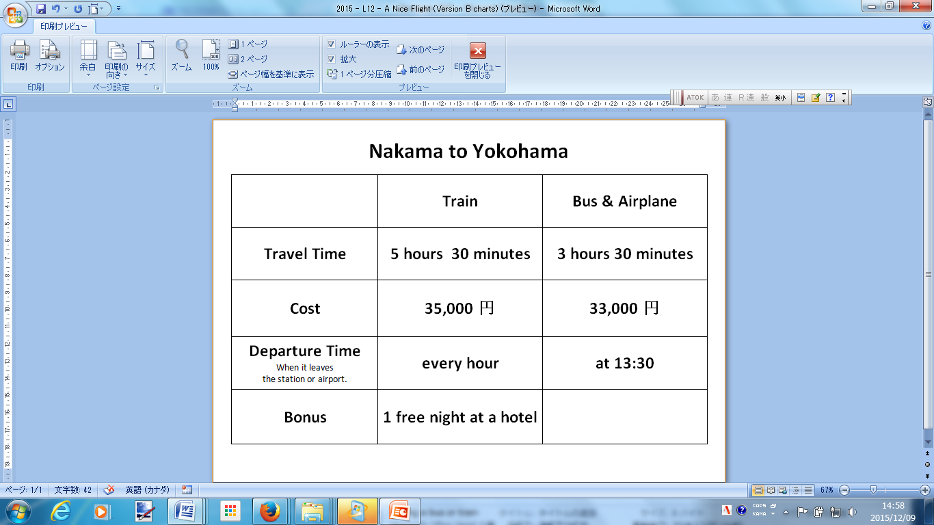

Tell them to make groups of 4 or 5 students.

Give them worksheet A1 which they will be writing on.

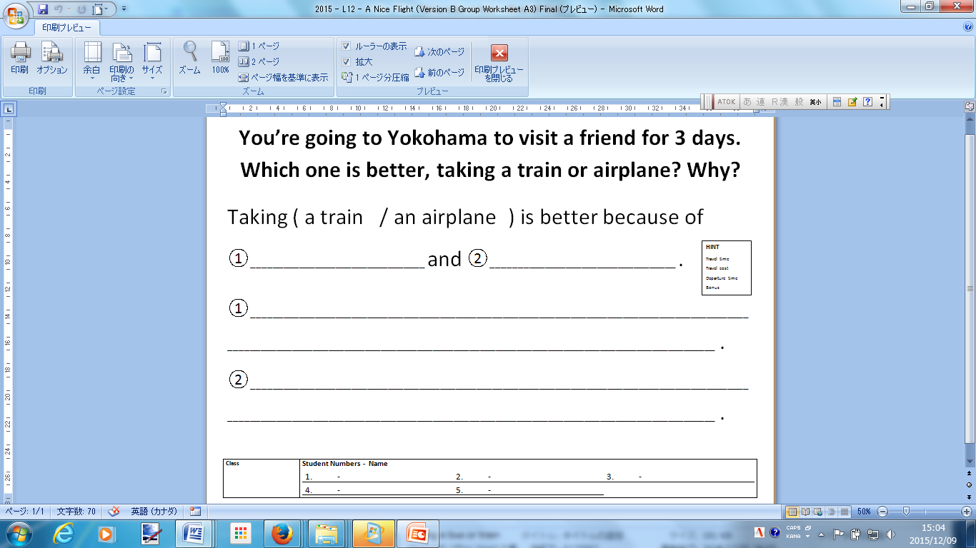

Students are given 10 – 15 minutes to write their names and answer the question.

ALT and JTE will walk around the class helping students with the correct grammar.

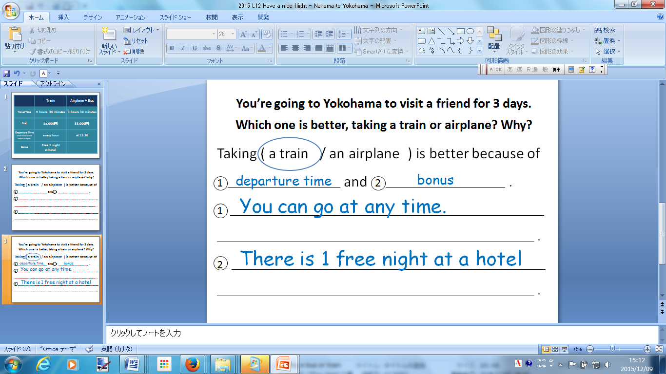

When students a finished writing they will read their answers to the rest of the class.

Notes: This lesson was simplified to reduce the amount of information the students have to work with such as waiting time for an airplane. Students were also allowed to answer with information not on the chart such as fear of flying.